

Software Engineering Department
Ort Braude College

Capstone Project Phase A

Sports Events

25-2-D-28

Names of team members :

Ahmad Abo Jabal & Mohammad Dukhi

Name of the supervisor :

Dr. Zeev Frenkel

GitHub Repository:

https://github.com/MoDukhi6/Sport_Events.git

Table of Contents

Table of Contents 2
Abstract 3
1. Introduction 4
1.1 Background and Motivation 4
1.2 Problem Statement 4
1.3 Current Solutions 4
1.4 Our Solution 5
1.5 Stakeholders and Benefits 6
1.6 Structure of the Book: 6
2. Literature Review and Related Work 6
2.1 Existing Tools and Platforms 7
Sports News and Live Results 7
Ticketing Systems 7
Prediction and Analytics Applications 7
2.2 Methods and Technologies 8
2.3 Addressing Software Needs 8
3. Expected Achievements 9
3.1. Outcomes 9
3.2. Unique Features 9
3.3. Algorithm & System Operation 10
3.4. Criteria for Success 12
❖ Personalized Recommendations 12
❖ Efficient Ticket Booking 12
❖ Real-Time Data Integration 12
3.5. Use Case Diagram 13
4. Engineering Process 13
4.1. Process 13
4.1.1 Activity Diagrams - Admin Panel 15
4.1.2 Activity Diagrams - Features 15
4.1.2 Activity Diagrams - Ticket Booking Flow 16
4.2. Product 17
Algorithms: 18
● Data Structure: 23
● User Interface 24
5. Testing and Evaluation 26
5.1. Test Plan Overview 26
5.2. Test Strategies 26
5.2.1 Unit Testing 26
5.2.2 Integration Testing 26
5.2.3 System Testing 27
5.2.4 Performance & Load Testing 27
5.2.5 User Acceptance Testing 28
5.3 Test Constraints and Assumptions 28
5.4 Test Environment 29
References 30

Abstract
This project presents the design and development of a smart sports event platform that streamlines ticket booking, enhances user engagement, and leverages artificial intelligence for predictive analytics and personalized recommendations. The system aims to centralize access to real-time sports information, including live scores, event news, and intelligent ticket suggestions, offering a seamless and intuitive experience for both fans and event organizers.
The engineering process followed a structured, Agile-inspired methodology, consisting of iterative sprints that guided the development of core functionalities—from user interface design to backend architecture and AI model integration. Key features include a match prediction engine based on historical data, a hybrid recommendation system, and a heuristic-based seat selection algorithm that optimizes for user preferences and venue conditions.
The platform will be built using modern technologies, we plan to use Flutter for the frontend, JavaScript for the backend, Firebase for data storage, and tensorFlow for machine learning tasks. Testing will be conducted across multiple layers—unit, integration, system, and performance—to ensure robustness, scalability, and usability.
By combining real-time data feeds, predictive intelligence, and user-centered design, this platform offers a forward-looking solution for the digital transformation of sports event management. The outcome is a highly responsive, intelligent, and efficient system that meets the needs of modern sports enthusiasts and event organizers alike.

Introduction

1.1 Background and Motivation
In today’s fast-paced world, sports fans seek not only real-time updates, news, and match statistics but also a seamless and user-friendly ticketing experience. Despite the abundance of specialized apps and websites, consumers remain frustrated by having to use multiple platforms to access information and purchase tickets. Popular sports data providers like ESPN [1], SofaScore [2], and FlashScore [3] deliver live scores and analytics, while ticketing platforms such as Ticketmaster [4] and StubHub [5] focus solely on seat booking. This fragmentation complicates the fan experience, leading to inefficiencies and missed opportunities, particularly when key decisions need to be made quickly. The increasing pace of sports events and the rapid dissemination of news further emphasize the need for an integrated platform that caters to the diverse and evolving requirements of sports enthusiasts.

1.2 Problem Statement
The current sports ecosystem is highly fragmented, requiring fans to rely on multiple platforms for different services. Live scores are accessed through one application, while sports news is read on another. Ticket booking takes place on separate portals that often lack smart recommendations, and additional sources are needed for information such as player statistics, match predictions, historical data, and updates on upcoming events.
This fragmented approach results in inefficiencies, a poor user experience, limited personalization, and challenges in event management for organizers. Fans waste valuable time switching between platforms, data is not synchronized in real time, and each service offers only a narrow slice of the overall fan experience.
The lack of a centralized, intelligent platform that seamlessly integrates all aspects of the sports experience highlights a significant gap in today’s sports technology ecosystem.

1.3 Current Solutions
Existing services like ESPN or Ticketmaster focus on specific needs but don’t provide an all-in-one experience. Platforms remain siloed, forcing fans to manually piece together information, which reduces convenience and engagement.

1.4 Our Solution
We aim to develop a Smart Sports Events Application. a centralized mobile platform that delivers an all-in-one experience for everyone. The app will integrate real-time sports data, AI-powered recommendations, and intelligent ticketing features, all within a user-friendly and modern interface.
The application will include the following features:
- Live scores and match updates integrated via external sports APIs (e.g., SportRadar, API-Football)
- Smart ticket booking with real-time seat availability and interactive seat maps
- Personalized content feed, powered by machine learning models that analyze user behavior, preferences, and historical data
- Match forecasts and predictions, using classification algorithms (e.g., decision trees or logistic regression)
- AI-based recommendations for matches and events based on user interests and app usage patterns
- Player/team insights, game history, and upcoming fixtures, all pulled from structured external datasets
We plan to use Flutter for the cross-platform mobile frontend, Firebase for real-time database and authentication, and Python with libraries such as scikit-learn, pandas, and TensorFlow for implementing machine learning models. Backend services may use Node.js or Firebase Functions to handle logic and secure data operations.

Expected Challenges:
- Pushing real-time updates to make sure the user will get updates on the fly.
- A secure login system to protect user credentials.
- Ensuring performance while handling real-time updates, especially during live events.
- Training meaningful AI models with limited sports data early in development.
- Creating a responsive and smooth UX/UI across devices.
Why We’re Ready:
As software engineering students in our final year, we have practical experience in building full-stack systems. We've selected tools like Python and Firebase to accelerate development and handle scalability, and we’ve planned our timeline to accommodate both research and development phases. With proper planning, resource allocation, and continuous feedback, we believe we’re well-prepared to overcome these challenges and deliver a successful solution.

1.5 Stakeholders and Benefits
- Fans: One-stop solution for all sports content and ticketing.
- Events Organizers: Better data, smarter ticketing, improved crowd control.
- Ticketing Agencies: Streamlined processes and enhanced analytics.
- Sponsors: Targeted campaigns based on user behavior and event data.
This unified platform boosts engagement, efficiency, and value across the sports ecosystem.

1.6 Structure of the Book:
This project book is organized into several key chapters that follow the full software development lifecycle. Chapter 2 presents the Literature Review and Related Work, exploring existing tools and technologies related to sports event booking platforms. Chapter 3 outlines the Requirements Analysis and System Design, including both functional and non-functional requirements, as well as the proposed system architecture. Chapter 4 details the Implementation phase, describing the technologies used and the development process. Chapter 5 focuses on Testing and Evaluation, presenting the methods used to test the system's functionality, performance, and user experience. Finally, Chapter 6 provides the Conclusion and Future Work, summarizing the outcomes of the project and suggesting possible directions for future enhancements.

Literature Review and Related Work
This chapter reviews the tools and methods currently available to address the fragmented sports ecosystem. It examines existing platforms that span multiple domains—including sports news, live results, ticketing, predictions, and additional fan engagement features. The goal is to understand how current solutions operate, identify their shortcomings, and highlight approaches that will inform the design of our integrated sports platform.

2.1 Existing Tools and Platforms
Several commercial platforms currently serve specific niches within the sports digital ecosystem. These platforms are generally specialized, and while they excel in their respective functions, they lack features, personalizations, and an all-in-one user experience.

Sports News and Live Results
Platforms such as ESPN [1] , SofaScore [2] , and FlashScore [3] are widely used for real-time sports results, in-depth statistics, and news coverage across various sports.
- ESPN offers comprehensive coverage, including articles, match previews, and live commentaries, but it operates primarily as a media outlet and does not include services such as ticketing or personalized features.
- SofaScore provides detailed player statistics and live ratings but focuses mainly on the live experience, not pre-game recommendations or post-game analysis.
- FlashScore delivers fast score updates and betting odds integration but offers minimal user customization or event engagement features.

Ticketing Systems
Applications like Ticketmaster [4], StubHub [5], and SeatGeek [6] provide platforms for sports ticket purchasing, often featuring interactive seat selection and dynamic pricing.
While these tools serve a critical function for fans attending live events, they operate in isolation from broader fan engagement platforms. They typically do not include real-time sports data, content personalization, or AI-based recommendations, which limits their ability to create a connected sports experience.

Prediction and Analytics Applications
Some sports prediction platforms and betting tools, such as Bet365 [7] or AI-powered apps like Forebet [8], use statistical models and historical data to forecast outcomes. These tools use machine learning algorithms like logistic regression or decision trees to predict results.
However, their primary goal is gambling-related forecasting, and they typically lack integrations with fan-centered services such as personalized news feeds, event discovery, or ticket booking.

2.2 Methods and Technologies
To build a platform that addresses these varied needs, several modern methods and technologies are being applied across the industry:
- Data Aggregation and API Integration:
Leading sports platforms rely on well-established APIs from providers such as SportRadar and Football-Data.org to obtain live scores, statistics, and news updates. Coupled with web scraping techniques, these methods ensure comprehensive data coverage, although they present challenges in maintaining data consistency and update frequency.
- Artificial Intelligence and Machine Learning:
Hybrid recommendation systems—using a combination of collaborative and content-based filtering—are increasingly used to personalize content for users. Such systems can tailor news feeds, recommend events, and even optimize seating suggestions. In addition, predictive models, ranging from logistic regression to deep learning algorithms, have shown promise in forecasting match outcomes and player performance, thereby enhancing the decision-making process for fans.
- Real-Time Data Processing:
Technologies like Firebase Realtime Database, Socket.IO, Apache Kafka, and Google Pub/Sub are key to ensuring that users receive real-time updates on live scores, ticket availability, and event changes. These tools are essential for maintaining a dynamic, responsive platform under high-demand conditions.

2.3 Addressing Software Needs
The literature and existing tools reveal that while specialized platforms provide excellent features within their domains, the sports fan experience remains fragmented. The academic and industry research underscores the importance of an integrated system that can:
- Unify diverse sports content—from news and live scores to ticket booking and predictive insights—into a single, seamless interface.
- Leverage AI to personalize recommendations and provide smart, real-time event insights.
- Ensure operational efficiency and responsiveness through advanced data aggregation and real-time processing techniques.
In summary, an integrated sports platform that consolidates news, live scores, predictions, and ticketing services is not only feasible but also necessary to address the current gaps. The insights gained from the literature and existing tools clearly support the development of a comprehensive solution that enhances the overall fan experience, streamlines event management, and leverages technology to deliver timely, personalized information.

Expected Achievements

3.1. Outcomes
In this chapter, we define the concrete products, modules, and algorithms that will be developed, and establish clear success criteria. Our goal is to deliver a unified sports platform that integrates news, live results, AI‑driven predictions, personalized recommendations, and smart ticket booking—all in one seamless system. Through a user-centric design approach, the application will ensure usability and significantly enhance overall user satisfaction.

3.2. Unique Features
3.2.1. AI-Powered Recommendations
At the core of the Smart Sports Platform is the AI-powered recommendation system, which analyzes user preferences and provides tailored event suggestions. This feature involves integrating machine learning algorithms to understand user behavior and optimize recommendation accuracy.

3.2.2. Smart Seat Selection
The smart seat selection feature allows users to find the best available seats based on their criteria, such as price, view, and proximity to amenities. This feature involves integrating real-time data on seat availability and user preferences to provide personalized seat recommendations.

3.2.3. Real-Time Event Insights
The real-time event insights feature provides users with up-to-date information on event schedules, ticket prices, and venue details. This feature involves integrating real-time data feeds from various sources to provide comprehensive event information.

3.2.4. AI‑Powered Prediction Engine
A machine learning model trained on historical match data, player metrics, and contextual features (home/away, weather).
Outputs win/draw/loss probabilities for upcoming matches.

3.2.5. User-Centric Interface
The Smart Sports Ticketing Platform will feature a user-centric interface that emphasizes accessibility and ease of use. The platform will incorporate real-time feedback mechanisms, allowing users to see immediate results as they interact with the application.

3.3. Algorithm & System Operation
Data Flow
1. Data Ingestion
We will ingest real-time and scheduled sports data from public and commercial APIs such as API-Football [9] and TheSportsDB [10].
- RESTful API calls will be used for scheduled fetching of news, fixtures, and team data.
- WebSockets or streaming endpoints (where supported) will handle live updates for scores and in-game statistics.
2. Data Processing (ETL)
ETL pipelines clean, normalize, and store data in a central database (Firebase) to automate:
- Cleaning (removing null/malformed data).
- Normalization (unifying date/time formats, player/team IDs).
- Storing the processed data in Cloud Firestore and Firebase Realtime Database.

3. Analytics & AI Processing
Our platform uses machine learning models for:
- Match result prediction using algorithms like logistic regression, XGBoost, or random forest, trained on historical game data.
- User recommendations via collaborative filtering or content-based filtering to suggest match seats and events.
Querying the database, run in real time, and write results back for display using Firebase ML Kit for mobile compatibility.

4. User Interaction Layer
The front end will be built using Flutter. It will communicate with the backend through:
- REST APIs (for scheduled data)
- WebSocket channels (for live updates)
- Firebase Cloud Messaging (FCM) for sending real-time notifications (e.g., goal alerts, ticket availability).
Key UI features include:
- Personalized dashboards (widgets)
- Event schedules and ticketing
- Live match stats

Seat Selection Algorithm (Example):
- Rank seats by distance from center and elevation.
- Filter out seats above the user's price threshold.
- Adjust ranking using crowd‑density predictions (to avoid congested areas).
- Presenting the best seat sections to the user.

3.4. Criteria for Success

Personalized Recommendations

- Success Metric: Recommendation model achieves 70% - 80% accuracy in offline testing, measured using precision, recall, and F1 score.
- Validation Method: Simulate user profiles and test the recommendation output against known preferences. Additionally, small-group (friends) testing will gather qualitative feedback on relevance.

Efficient Ticket Booking

- Success Metric: The booking process completes in less than 30 seconds.
- Validation Method:
  - Internal testing sessions simulating ticket selection and checkout.
  - Use performance monitoring tools to measure time between user input and system response.
  - Log errors or failures in mock scenarios.

Real-Time Data Integration

- Success Metric: API-driven updates appear in the app within 5 seconds of change detection, and the system maintains >99% uptime during simulated live events.
- Validation Method:
  - Mock data feeds will simulate live updates.
  - Logs and response times will be tracked via Firebase Analytics or other monitoring tools.

- User Satisfaction: Achieving a high level of user satisfaction through a user-friendly interface and personalized experience (this part of success criteria we will see after publishing our app).

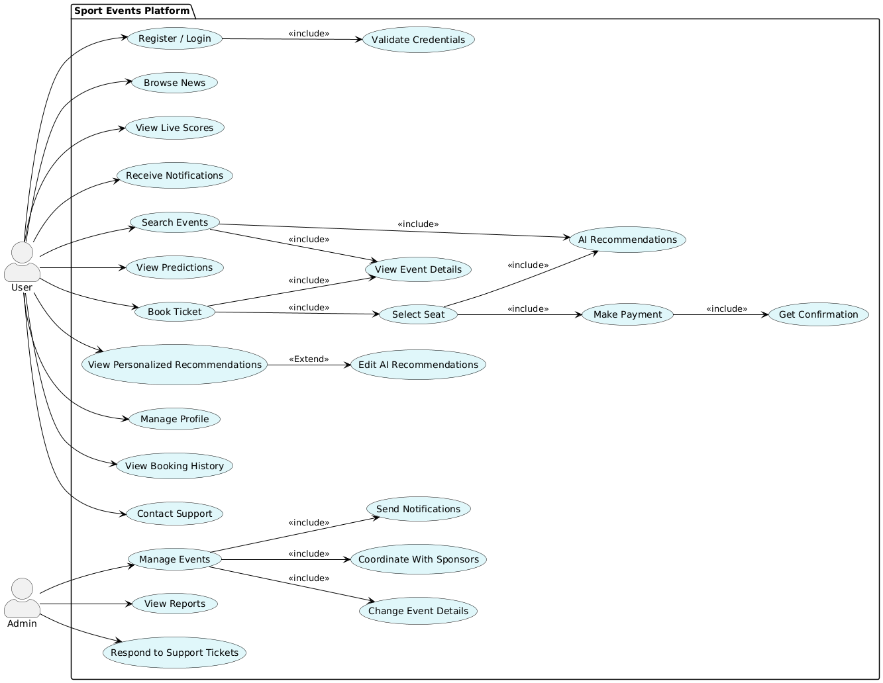
3.5. Use Case Diagram

4. Engineering Process

4.1. Process
The engineering process for this application is designed to be iterative and adaptable, allowing us to respond effectively to evolving requirements and challenges. The process is structured around the following key stages:
- Requirement Gathering and Analysis:
  - Description : This initial phase involved collecting and analyzing user requirements through a variety of methods. The goal is to gain a comprehensive understanding of the needs and preferences of sports fans, events, and ticketing agencies.
  - Methods Used: Surveys were distributed to a broad audience and friends of sports enthusiasts to gather quantitative data on their ticketing and viewing match insights habits. Interviews were conducted with event organizers and ticketing agencies to understand their operational challenges and requirements. Market research was performed to identify industry trends and competitive solutions.
  - Outcome: A detailed requirements specification data was gathered, outlining the functional (e.g., real-time news, ticket booking) and non-functional (e.g., performance, usability, security) requirements of the platform.
- System Design:
  - Description: Based on the requirements specification, we are designing the system architecture, including the frontend, backend, and database components. The design focused on scalability, maintainability, and security.
  - Architecture Overview: The system architecture comprises three main layers: The presentation layer (frontend), the application layer (backend), and the data layer (database). The frontend is an application built using Flutter, providing a user-friendly interface for interacting with the platform. The backend is made using Python which provides user authentication, event insights, and recommendation services. The database is a Firebase instance, storing user profiles, event details, and ticket information.
  - Technologies Used: Python, Flutter, Firebase, TensorFlow.
  - Rationale: Python was chosen for its versatility and seamless integration with modern front-end frameworks for building responsive user interfaces. Flutter was selected for building the mobile app frontend due to its cross-platform capabilities and rich UI components. Firebase was chosen for its flexible data modeling capabilities.
- Implementation:
  - Description: This phase involved developing the system functionalities based on the system design.
  - Key Components:
    - User Authentication: Implemented using JSON Web Tokens (JWT) for secure user authentication and authorization.
    - Ticket Booking: Implemented a ticket booking system with support for smart seat selection and real-time ticket availability. For example: the AI will recommend a specific seat location on the stadium according to user preferences such as crowd loud.
    - AI Match Predictions: Integrated lightweight AI models to predict match outcomes based on historical data, team statistics, and player performance.
    - Real-Time Event Insights: Implemented real-time data feeds for providing up-to-date information on event schedules, ticket prices, and venue details.
- Testing:
  - We use JUnit and Mockito to write and run unit tests for backend functions such as user authentication, ticket booking logic, and AI-based recommendation engines. These tests ensure that each module performs correctly in isolation.
  - For frontend validation, we use Flutter’s widget testing tools to simulate user interactions and UI behavior. This includes navigating through screens, selecting seats, and completing bookings.

4.1.1 Activity Diagrams - Admin Panel
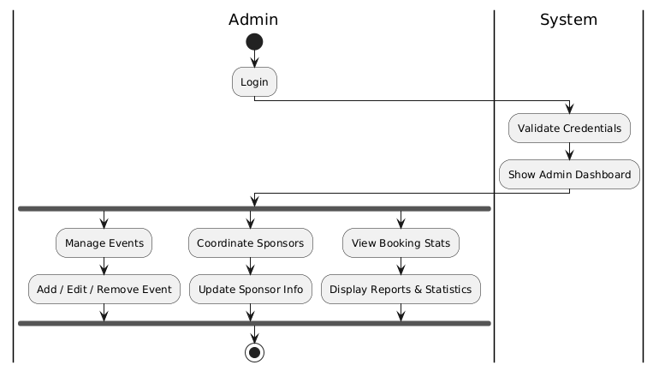

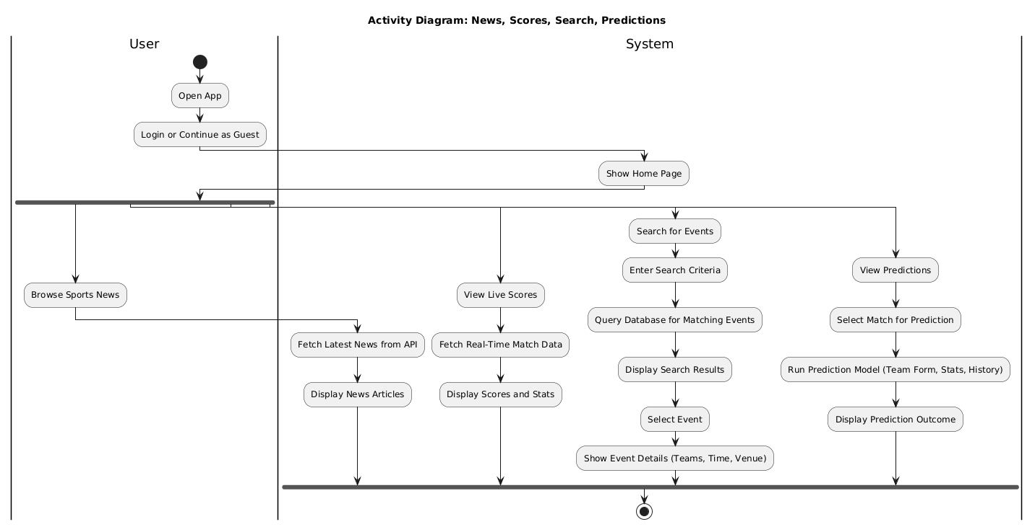
4.1.2 Activity Diagrams - Features

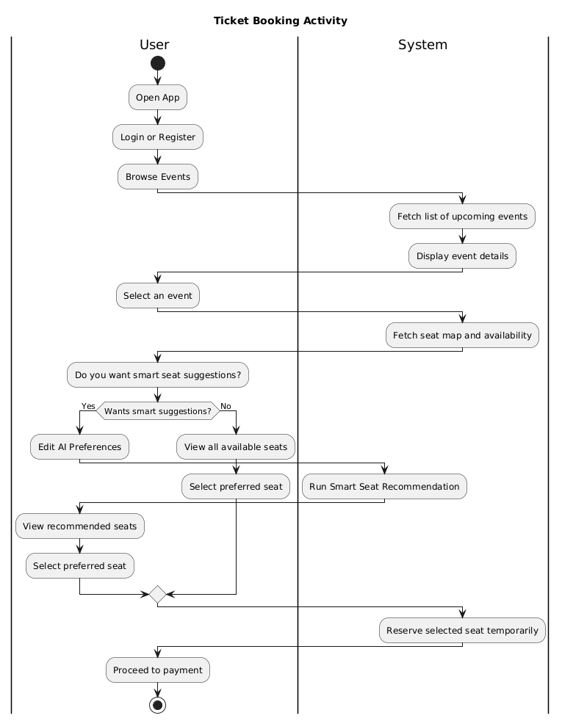
4.1.2 Activity Diagrams - Ticket Booking Flow

4.2. Product
System Architecture Diagram - User
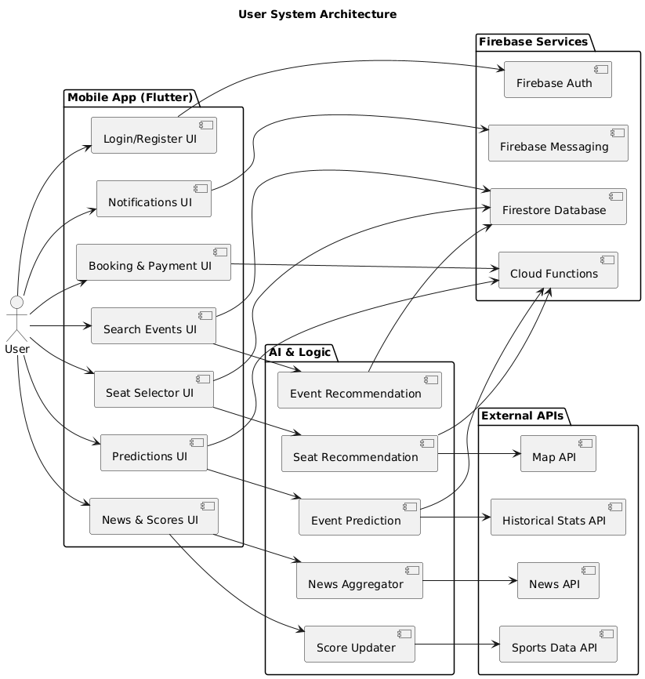
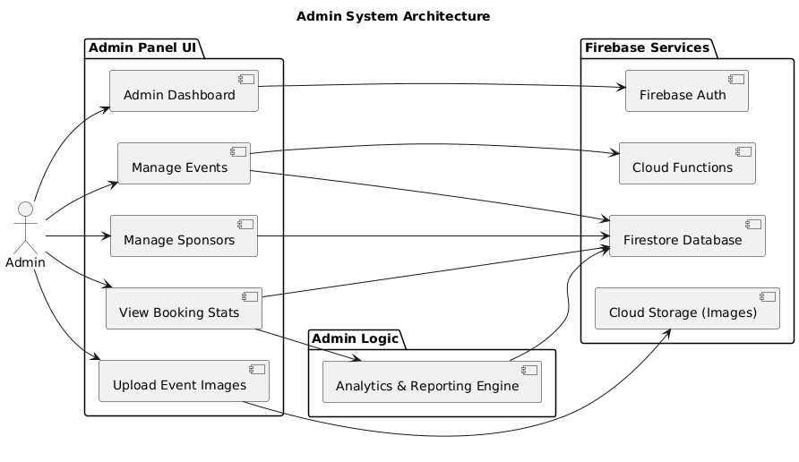
System Architecture Diagram - Admin

Algorithms:
- Seat Classification & Recommendation
Our recommendation system includes an AI-driven algorithm that classifies available seats based on user preferences. The goal is to enhance the personalization of ticket booking beyond just price and availability.
Seat Classification Logic:
Each seat is mapped using its coordinates (x, y), where the stadium center is treated as the origin. The algorithm calculates the Euclidean distance from each seat to the stadium center, and uses this distance to infer the level of crowd engagement and proximity to the field and when the user chooses their preferences the app will suggest the best seat sections for him.
- Seats closer to the center are labeled as “Loud Seats”, indicating a high-energy atmosphere, typically preferred by passionate fans.
- Seats farther from the center are labeled as “Less-Loud Seats”, ideal for families or users who prefer a calmer experience.
- User preferences (gathered from app settings or previous bookings): noise level, proximity to the field, side view vs. central view, etc.
- Seat price range
Pseudocode: Seat Classification & Recommendation:
Input:
- seats: list of all available seats with attributes:
- coordinates (x, y)
- price
- section (e.g., side, center, behind goal)
- occupancyRate (optional, if live data available)
- center: coordinates of the stadium center (x_c, y_c)
- userPreferences:
- noiseLevel: "Loud" or "Less-Loud"
- priceRange: [min, max]
- proximityPreference: "Close", "Medium", or "Far"
- preferredView: "Center", "Side", or "Any"
Process:
1. For each seat in seats:
a. Calculate distance = sqrt((x - x_c)^2 + (y - y_c)^2)
b. Store seat.distance = distance
2. Compute averageDistance = average of all seat.distance
3. For each seat:
a. If seat.distance < averageDistance:
seat.classification = "Loud Seat"
else:
seat.classification = "Less-Loud Seat"
4. Filter seats:
a. Match classification with userPreferences.noiseLevel
b. Match seat.price with userPreferences.priceRange
c. Match seat.section with userPreferences.preferredView
d. Optionally filter seats with occupancyRate > threshold
e. Optionally filter by proximity category:
- Close: seat.distance < 0.75 * averageDistance
- Medium: within ±25% of averageDistance
- Far: seat.distance > 1.25 * averageDistance
5. Score each remaining seat:
+1 point for matching all preferences
-1 point for price out of optimal range
-1 point if isolated (surrounded by low occupancy)
6. Sort filtered seats by score descending
Output:
- Return recommended seat sections.
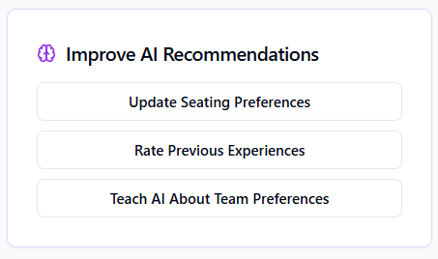
Here is an example of how the booking seats/AI recommendation screens would look like:
Here the user can edit his AI
Recommendations/Preferences

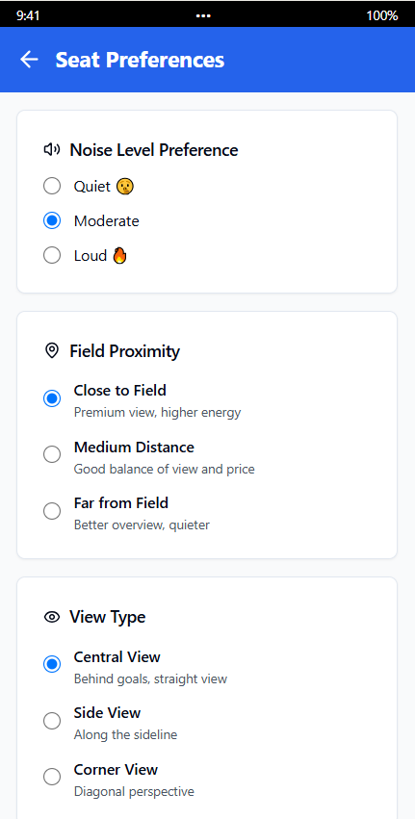
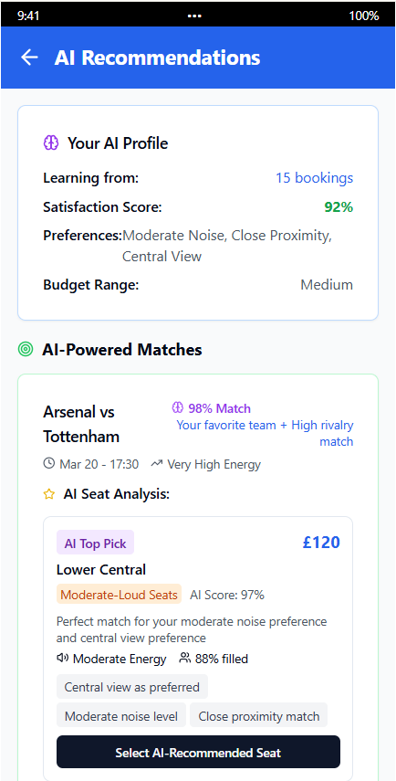

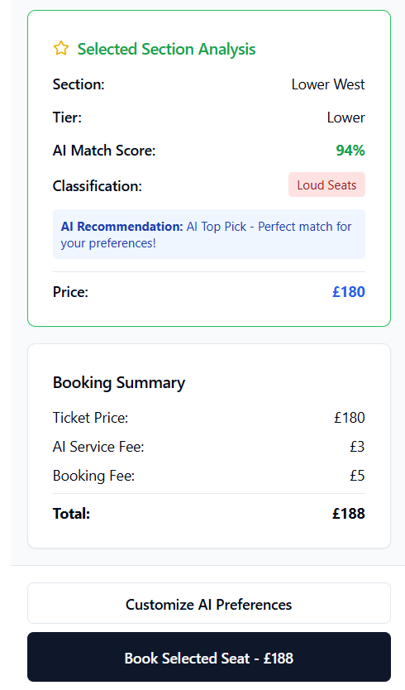
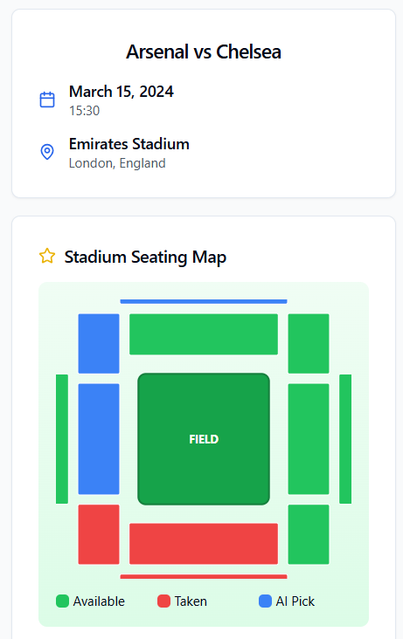

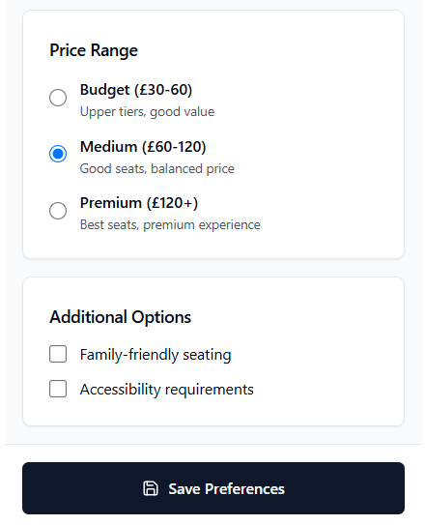

- Event Results Prediction
We also developed a prediction model to estimate the outcomes of upcoming sports events. It uses both historical and real-time data, allowing users to view forecasted results and win probabilities.
- Data Inputs: Team performance history, home/away stats, player news, weather conditions, social sentiment
- Algorithms Used:
  - Logistic Regression
  - Time Series Analysis
  - Natural Language Processing (for extracting key signals from news/social media)

Pseudocode: Event Outcome Prediction:
Input:
event_id
Process:
1. Fetch relevant data
historical_data = getHistoricalData(event_id)
team_stats = getTeamStatistics(event_id)
weather = getWeatherForecast(event_id)
sentiment_score = analyzeNewsAndSocialMedia(event_id)
2. Feature engineering
features = {
"team1_win_rate": team_stats.team1.win_rate,
"team2_win_rate": team_stats.team2.win_rate,
"team1_home_advantage": team_stats.team1.is_home,
"weather_impact": weather.condition_score,
"sentiment_score": sentiment_score
}
3. Load trained model
model = loadPredictionModel()
4. Predict outcome probabilities
prediction = model.predict_proba(features)
Output:
return {
"team1_win_probability": prediction[0],
"draw_probability": prediction[1],
"team2_win_probability": prediction[2]
}
Here is an example of how the prediction/analytics screens would look like:
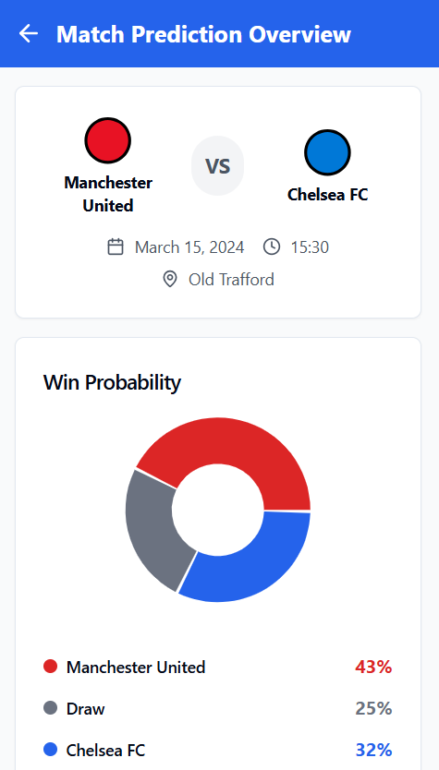
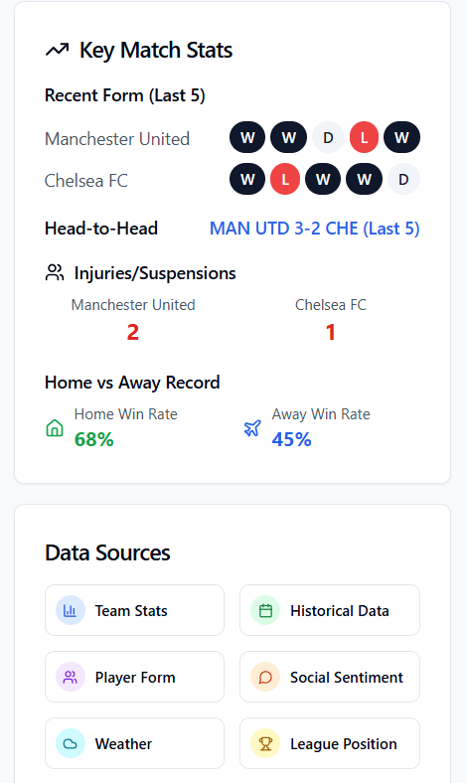

Data Structure:
1. User Profiles
Attributes: User ID, Username, Email, Password

2. Event Data
Attributes: Event ID, Team 1, Team 2, Date, Time, Stadium Name, Ticket Availability

3. Live Match Information
Attributes: Event ID, Team 1, Team 2, Date, Time, Stadium Name, Team 1 Score, Team 2 Score, Live Updates

4. Seat Information
Attributes: Seat ID, Stadium ID, Section, Seat Number, X-Coordinate, Y-Coordinate, Price Category, View Quality

5. Ticket Information
Attributes: Ticket ID, Event ID, Stadium Name, User ID, Team 1, Team 2, Section Number, Seat Number, Section ID, Number of available tickets, Number of remaining tickets.

6. Stadium Information
Attributes: Stadium ID, Name, Location, Capacity

7. Team Information
Attributes: Name, Number of Wins in Last 5 Matches, Number of Trophies, Badge

Class Diagram:
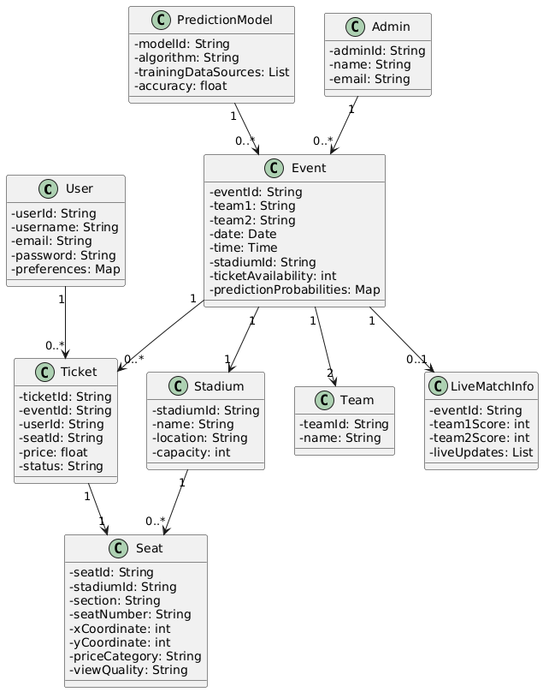

User Interface
Design Principles:
    - Simplicity: Easy to navigate and use.
    - Accessibility: Accessible to all users.
    - Real-Time Feedback: Provides immediate feedback to user actions.
Key Features:
    - Dashboard Home: Displays news feed, upcoming events, and live score ticker.
    - Personalized Recommendations: Recommends event’s tickets based on user preferences.
    - Event Detail Page: Shows match preview, prediction probabilities, statistics, and “Book Tickets” button.
    - Real-Time Event Insights: Provides up-to-date information on event schedules, ticket prices, and venue details.
    - Ticket Booking Section: Interactive seat map with recommended seats highlighted.
    - User-Friendly Interface: Intuitive design patterns and clear visual hierarchy.

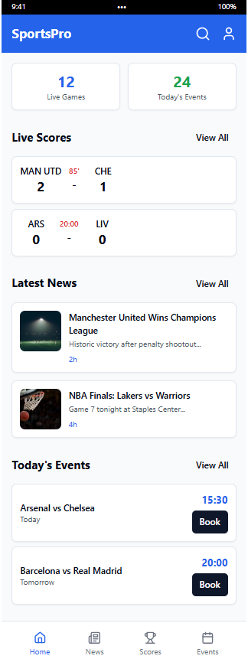

Examples of UI Screens:
Home Screen: News Screens:

5. Testing and Evaluation

5.1. Test Plan Overview
The primary goal of our test plan is to verify that each module of the sports platform functions correctly, meets its requirements, and integrates seamlessly into a robust, user‑friendly system. We will employ a combination of unit, integration, system, performance, and user‑acceptance testing to cover all functional and non‑functional aspects.

5.2. Test Strategies

5.2.1 Unit Testing
- Scope: Individual functions and classes in the prediction engine, recommendation system, data ingestion pipelines, seat‑selection algorithm, and REST API endpoints.
- Tools: Pytest for Python components; Jest for React front‑end.
- Approach:
  - Mock external API calls (e.g., sports data feeds, payment gateway).
  - Test edge cases (empty data, invalid inputs, error handling).
  - Ensure ≥ 90% code coverage on critical modules.

5.2.2 Integration Testing
- Scope: Interaction between back‑end services (e.g., database ↔ prediction engine, API ↔ front‑end).
- Tools: Postman/Newman for API workflows; Cypress for UI–API integration.
- Approach:
  - Validate data flows end‑to‑end (e.g., ingest news → store in database → display on dashboard).
  - Test booking workflow: seat selection → payment → ticket confirmation.
  - Verify real‑time updates.

5.2.3 System Testing
- Scope: Entire application running in a staging environment.
- Tools: Selenium for cross‑browser UI tests; custom scripts for backend health checks.
- Approach:
  - Execute full user journeys (browse news, view live scores, run predictions, book tickets).
  - Confirm that success criteria from Chapter 3 (e.g., API response times, prediction accuracy) are met.

5.2.4 Performance & Load Testing
- Scope: Assess responsiveness under high concurrency and data volume.
- Tools: JMeter or Locust for load generation.
- Approach:
  - Simulate 100+ concurrent users browsing dashboards and booking tickets.
  - Measure API latencies (target ≤ 200 ms) and WebSocket update lags.
  - Identify bottlenecks in database queries or model inference.

5.2.5 User Acceptance Testing
- Scope: Real users (sports fans and event managers) validate usability and feature completeness.
- Approach:
  - Prepare test scripts covering core functions.
  - Collect qualitative feedback on UI/UX and recommendation relevance (target ≥ 4/5 satisfaction).
  - Iterate on improvements before final deployment.

5.3 Test Constraints and Assumptions
- Test Data Availability:
  - Historical match datasets and user profiles must be prepared in advance. We assume access to clean, representative samples.
- Time Constraints:
  - Testing must fit within the semester timeline; therefore, automation is critical. Some exploratory manual tests may be limited.
- Network Reliability:
  - Real‑time features depend on Internet connectivity. We assume a stable test network; intermittent outages will be simulated but not fully covered.

5.4 Test Environment
Component | Configuration / Tooling
Staging Server | AWS EC2 t3.medium; Docker containers; Nginx reverse proxy
Database | Firebase
Backend | Firebase Cloud Functions (Node.js)
Front‑end | Flutter
CI/CD Pipeline | GitHub Actions; automated build → test → deploy
Load Testing | Locust 2.9 / k6
Monitoring & Logging | Firebase-native tools
By following this precise test plan—mindful of constraints, benefiting from automation, and closely monitoring performance—we will ensure that our sports platform meets its functional requirements, achieves the performance targets outlined in Chapter 3, and delivers a high‑quality experience for all stakeholders.

References
[1] ESPN: (espn.com)
[2] SofaScore: (sofascore.com)
[3] FlashScore: (flashscore.com)
[4] Ticketmaster: (ticketmaster.com)
[5] StubHub: (stubhub.com)
[6] SeatGeek: (seatgeek.com)
[7] Bet365: (bet365.com)
[8] Forebet: (forebet.com)
[9] API-Football: (https://www.api-football.com)
[10] TheSportsDB: (https://www.thesportsdb.com)

